
Lesson 5: Enemy Ranks
GDevelop
VIDEO GAME CREATION
This week: one enemy becomes many. Your job is to turn last week's single enemy into a whole row of them, using a loop instead of repeating yourself by hand.
Open your own [YourName]Game project from Lesson 4 - don't start a new one. Everything this week builds on the enemy and collision detection you already have.
Tip: no new assets this week - you're reusing bullet_yellow.png, sfx_shoot.wav, enemy_invader_red.png, and sfx_hit.wav from your Lesson 3 and 4 Assets folders.

Setup
- Open your [YourName]Game project from Lesson 4.
- Delete the single Enemy instance you manually placed on your scene last week.
- Add a new scene variable named EnemyIndex (Scene Properties > Scene Variables), default value 0.

Level 1 - Minimal (MVP)
Several enemies sit on screen in a row, created by a loop instead of placed or spawned one at a time. Shooting any one of them destroys just that one. This is a complete finish for today - reaching this is enough to move on to next week.
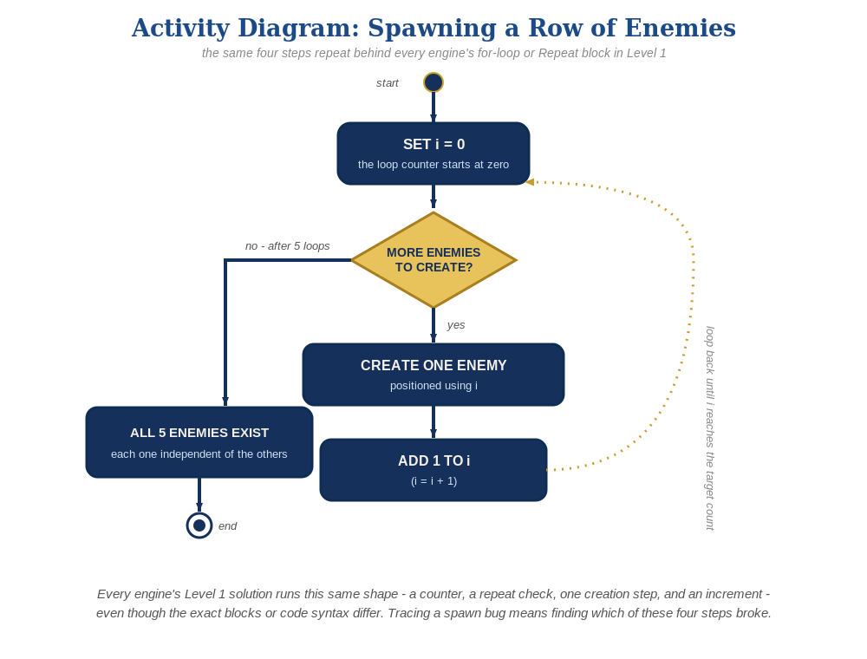
The spawn loop, in general - the same counter, repeat check, creation step, and increment behind Level 1 in every engine, whatever the exact blocks or syntax look like.
- At the beginning of the scene, add a "Repeat 5 times" event. Inside it, add an action to create an Enemy instance at a position based on EnemyIndex, then increment EnemyIndex (code below).
- Click the green Preview button - you should see a row of enemies, and shooting any one of them should destroy just that one.
At the beginning of the scene:
Repeat 5 times:
Action: Create object Enemy at (40 + EnemyIndex * 80, 40)
Action: EnemyIndex = EnemyIndex + 1

Level 2 - Complete (Alpha/Beta)
Every enemy in the row can be individually shot and destroyed without affecting the others, and a bullet that misses every enemy still behaves exactly like it did last week.
- Shoot several different enemies in a row, including some misses - each hit deletes exactly the one Enemy instance that was actually touched, and every other enemy is unaffected.
- This already works with no extra code: the "Bullet is in collision with Enemy" condition and its Delete actions already operate per pair of overlapping instances, so every instance the Repeat event creates behaves independently and correctly, exactly the way Lesson 4 built it.

Level 3 - Refined (Ready to Publish) - pick any that interest you
- Sound: this already works with no changes - the "Play a sound" action in the Combat event group runs independently for every enemy that gets hit.
- Visual: give each Enemy a different "Tint color" as it's created, based on whether EnemyIndex is even or odd, for a striped row effect. GDevelop's Tint color action takes an "R;G;B" string - use "200;25;55" (a deep crimson red) for even-indexed enemies and "230;100;130" (a lighter dusty rose/pink) for odd-indexed ones, so every other enemy is a visibly different shade of red rather than a blended new color.
- Structure: keep the spawn Repeat event's only job being creating and positioning enemies - group it under its own labeled event group (e.g. "Spawn Enemies"), separate from the "Combat" group from Lesson 4.

If Something's Wrong
- All enemies stack on top of each other: confirm EnemyIndex is actually being incremented inside the Repeat event, and used in the position action.
- Only one enemy appears: confirm the Repeat event's count is actually set to 5 (or your chosen number), not 1.
- Old and new enemies both appear: confirm the manually-placed Lesson 4 Enemy instance was actually deleted from the scene.

Want More?
Student Resource List > GDevelop section, or gdevelop.io/tutorials

